Figure 1: Heavy Metal Correlation Matrix with Hierarchical Clustering
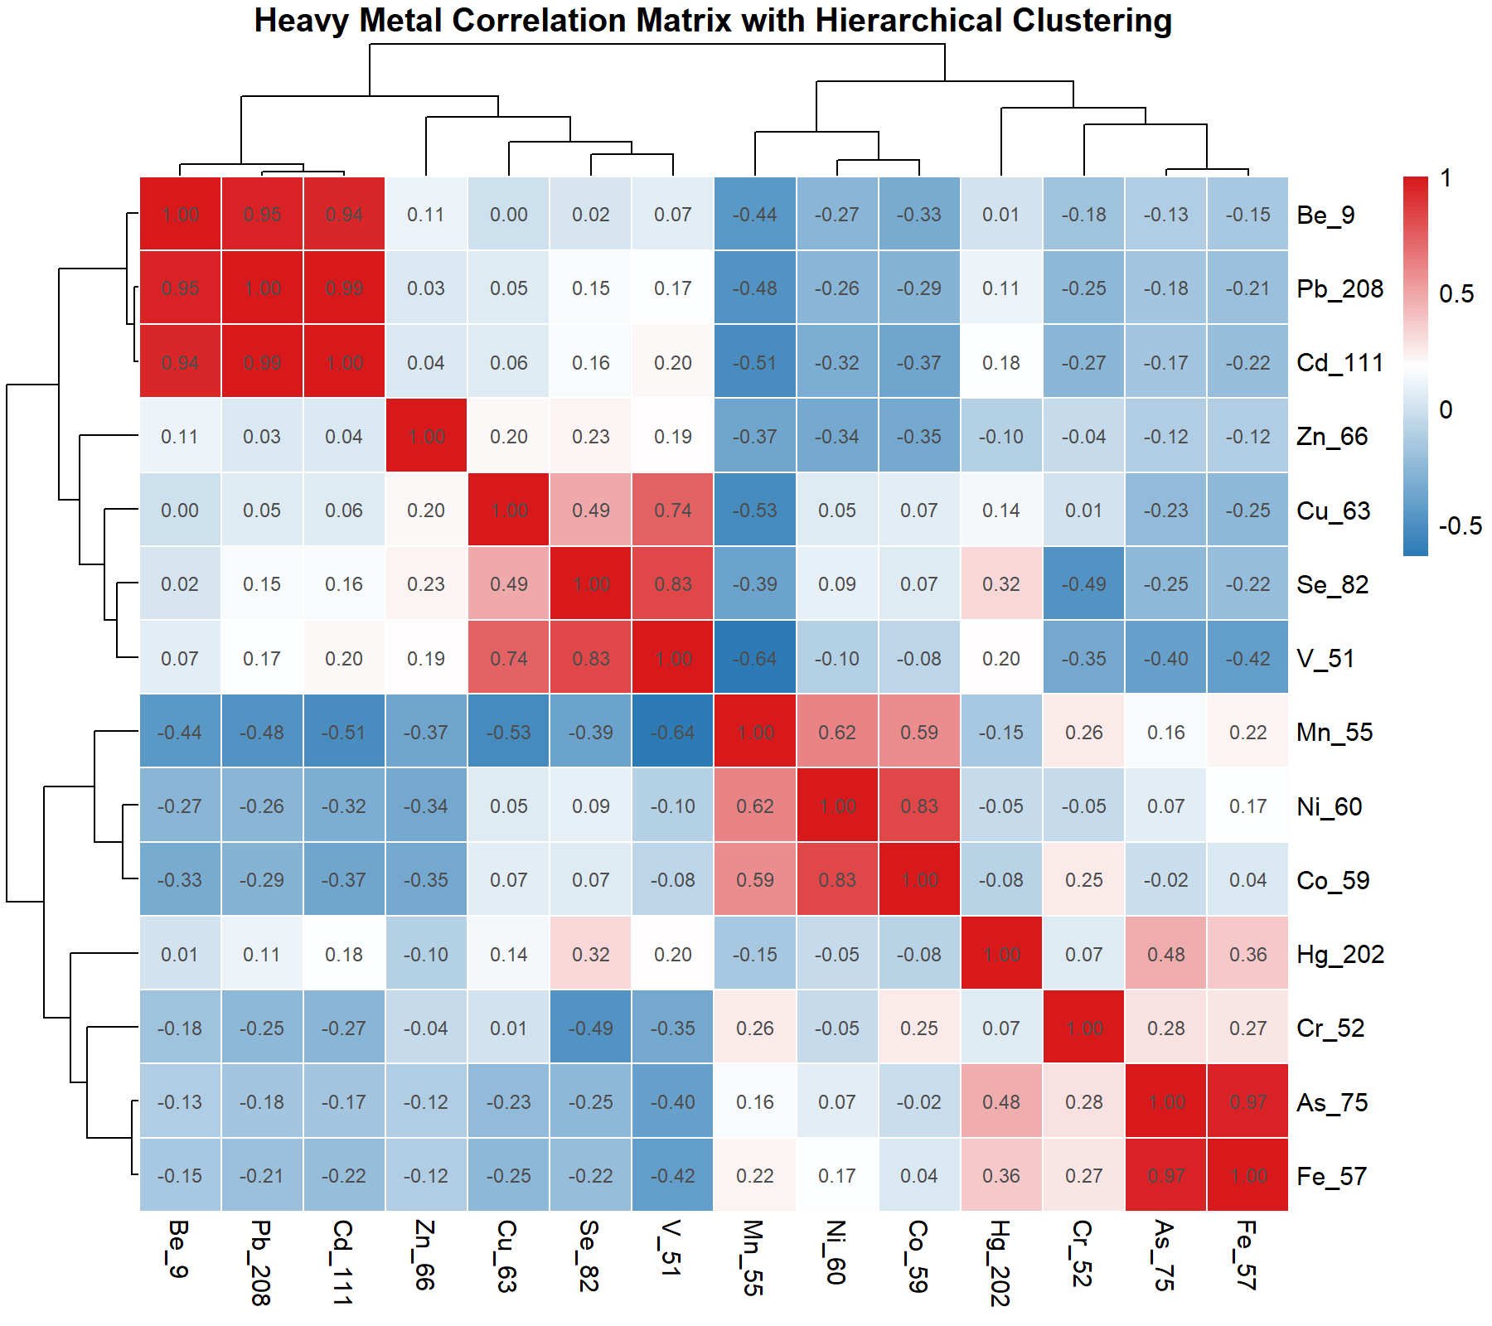
Figure 1. Pearson correlation matrix with hierarchical clustering of 14 heavy metals across environmental samples. Colour scale: deep red (r ≈ +1.0, strong positive) to deep blue (r ≈ −0.5, strong negative).

Description
The matrix reveals four distinct geochemical groupings resolved by hierarchical clustering. The first cluster, comprising Be, Pb, and Cd, exhibits exceptionally strong positive inter-correlations (r = 0.94–1.00), indicating a common anthropogenic source — most likely industrial smelting, battery manufacturing, or fossil fuel combustion — consistent with their well-established co-occurrence in contaminated soils and sediments (Liu et al., 2018; Järup, 2003).

The second cluster, encompassing Cu, Se, and V, displays moderate-to-strong positive associations (r = 0.49–0.83), suggestive of a shared geogenic or mixed anthropogenic origin such as petroleum-derived inputs or agricultural amendments (Kabata-Pendias, 2010). Within this cluster, V and Se show the tightest co-variation (r = 0.83), potentially reflecting vanadium-rich fuel oil combustion as a point source (Nriagu & Pacyna, 1988).

A third cluster — Mn, Ni, and Co — demonstrates strong internal coherence (r = 0.59–0.83) while displaying moderate-to-strong negative correlations with the Be–Pb–Cd group (r = −0.27 to −0.51). This inverse relationship may reflect contrasting redox-sensitive geochemical behaviour under fluctuating anaerobic and aerobic conditions in sediment profiles (Tessier et al., 1979).

The fourth cluster, consisting of Hg, Cr, As, and Fe, exhibits moderate internal associations (r = 0.25–0.97), with As and Fe showing the strongest mutual correlation (r = 0.97), consistent with the well-documented adsorption of arsenate onto iron oxyhydroxide mineral surfaces (Smedley & Kinniburgh, 2002). Hg shows relatively weak correlations with all other metals, suggesting an independent emission source, possibly artisanal gold mining or chlor-alkali industrial activities (Pirrone et al., 2010). Zn occupies an intermediate position between clusters, potentially reflecting its multi-source character spanning both geogenic and anthropogenic pathways (Alloway, 2012).

References
Alloway, B.J. (2012). Heavy Metals in Soils: Trace Metals and Metalloids in Soils and their Bioavailability (3rd ed.). Springer, Dordrecht.
Järup, L. (2003). Hazards of heavy metal contamination. British Medical Bulletin, 68(1), 167–182.
Kabata-Pendias, A. (2010). Trace Elements in Soils and Plants (4th ed.). CRC Press, Boca Raton.
Liu, J., Duan, C., Zhang, X., Zhu, Y., & Lu, X. (2018). Potential toxicity assessment of heavy metals in river sediments from the industrialised zone, China. Environmental Science and Pollution Research, 25(2), 1329–1341.
Nriagu, J.O., & Pacyna, J.M. (1988). Quantitative assessment of worldwide contamination of air, water and soils by trace metals. Nature, 333(6169), 134–139.
Pirrone, N., et al. (2010). Global mercury emissions to the atmosphere from anthropogenic and natural sources. Atmospheric Chemistry and Physics, 10(13), 5951–5964.
Smedley, P.L., & Kinniburgh, D.G. (2002). A review of the source, behaviour and distribution of arsenic in natural waters. Applied Geochemistry, 17(5), 517–568.
Tessier, A., Campbell, P.G.C., & Bisson, M. (1979). Sequential extraction procedure for the speciation of particulate trace metals. Analytical Chemistry, 51(7), 844–851.

Figure 2: Scree Plot for Heavy Metal PCA
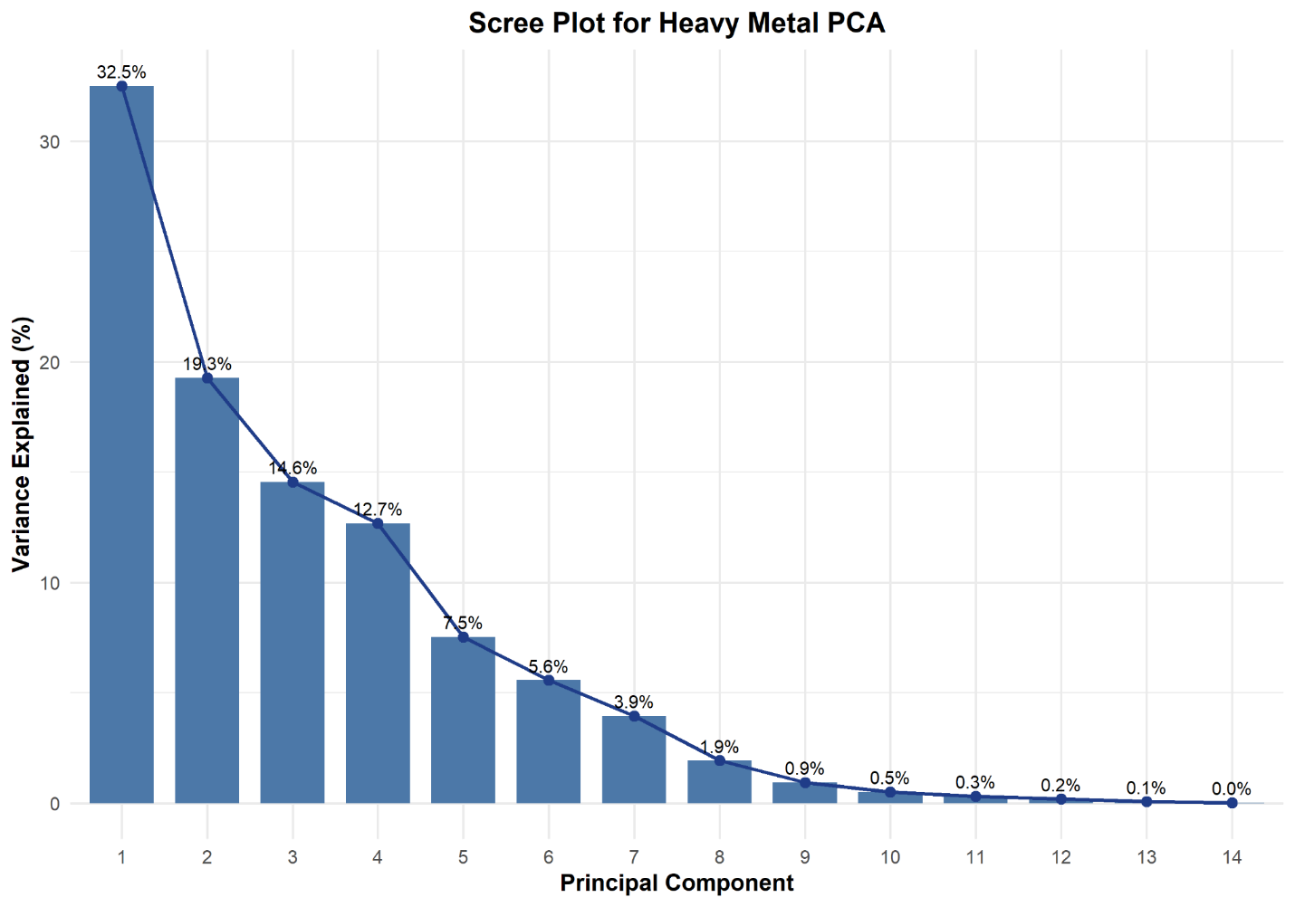
Figure 2. Scree plot showing the percentage of total variance explained by each of the 14 principal components extracted from the heavy metal dataset. Bar heights represent individual PC contributions; the superimposed line traces the cumulative decline in explanatory power.

Description
Principal Component 1 (PC1) accounts for the largest share of variance (32.5%), demonstrating that the dominant mode of geochemical variability across samples is primarily controlled by a single, powerful factor — most likely the anthropogenic contamination gradient associated with the Be–Pb–Cd cluster identified in Figure 1. PC2 and PC3 explain 19.3% and 14.6% of variance, respectively, reflecting secondary and tertiary sources or geochemical processes such as natural lithogenic inputs or redox-driven metal mobility.

The first four components collectively account for approximately 79.1% of total variance, which exceeds the commonly applied retention threshold of 70–80% (Kaiser, 1960; Jolliffe, 2002). A pronounced "elbow" is observable between PC4 and PC5 (transition from 12.7% to 7.5%), providing graphical justification for retaining four principal components in subsequent analyses, consistent with Kaiser's eigenvalue-greater-than-one criterion. Beyond PC5, the marginal contributions of each successive component fall below 7.5% and decline continuously toward zero, indicating that these components represent noise or minor analytical variation rather than ecologically or geochemically meaningful pollution sources (Reimann et al., 2008). This dimensionality reduction from 14 measured variables to 4 interpretable components demonstrates that the heavy metal contamination in the study area is driven by a limited number of identifiable geochemical and anthropogenic processes.

References
Jolliffe, I.T. (2002). Principal Component Analysis (2nd ed.). Springer, New York.
Kaiser, H.F. (1960). The application of electronic computers to factor analysis. Educational and Psychological Measurement, 20(1), 141–151.
Reimann, C., Filzmoser, P., Garrett, R.G., & Dutter, R. (2008). Statistical Data Analysis Explained: Applied Environmental Statistics with R. Wiley, Chichester.

Figure 3: PCA Biplot (PC1 vs PC2) for Heavy Metals
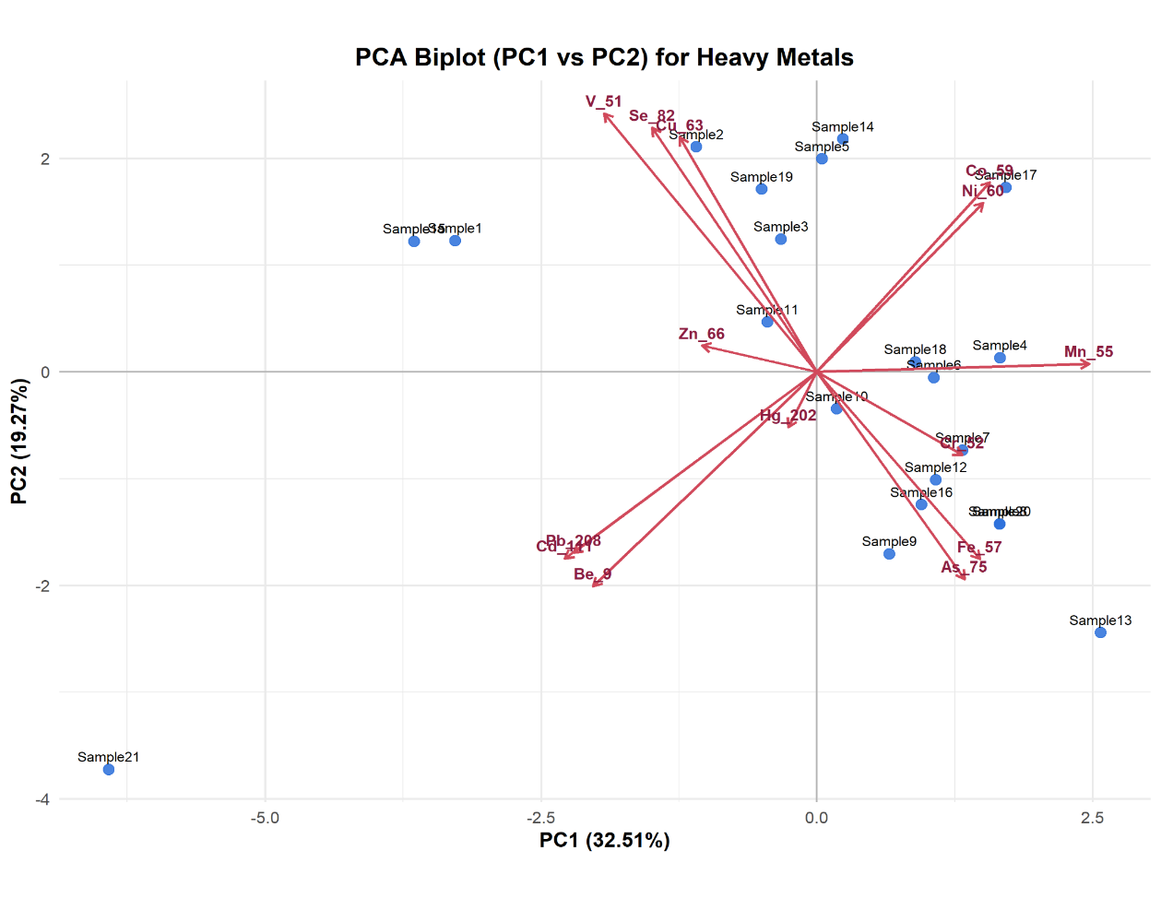
Figure 3. PCA biplot displaying 21 samples (blue dots) and 14 heavy metal loading vectors (red arrows) on the PC1 (32.51%) vs PC2 (19.27%) plane. Vector length indicates contribution to the respective axis; angular relationships approximate Pearson correlations between metals.

Description
The biplot provides an integrated visualisation of both inter-metal relationships and inter-sample geochemical differentiation. Along PC1, metals such as Mn, Co, and Ni project strongly in the positive direction, while Be, Pb, Cd, and to a lesser extent Cu, Se, and V project in the negative direction. This polarisation along PC1 reflects the primary contamination gradient, with samples positioned far in the negative PC1 direction (e.g., Samples 1, 3, 21, 35) exhibiting elevated concentrations of the Be–Pb–Cd suite — characteristic of industrial or traffic-related pollution sources (Facchinelli et al., 2001).

Conversely, samples in the positive PC1 region (e.g., Samples 4, 6, 13, 17) carry higher loadings of Mn, Co, and Ni — elements often associated with lithogenic parent material weathering or ferromanganese oxide cycling under natural geochemical conditions (Taylor & McLennan, 1985). Along PC2, the metals V, Se, and Cu point strongly upward, while As, Fe, and Pb project downward, indicating a secondary axis of variation potentially linked to differing redox conditions or source specificity. The upward projection of V may reflect petroleum combustion inputs (Nriagu & Pacyna, 1988), whereas the downward As–Fe association (r = 0.97, Figure 1) corroborates co-precipitation mechanisms at the sediment–water interface.

The near-parallelism of As and Fe vectors confirms their strong positive correlation, while the near-perpendicularity of Mn relative to Be and Cd vectors confirms their independent variance structure. Sample 21 represents a notable outlier, with extremely negative scores on both PC1 and PC2, suggesting anomalously high concentrations of Be, Pb, and Cd, possibly attributable to a localised point source of contamination (Reimann et al., 2008). Hg and Cr vectors are relatively short and centrally positioned, consistent with their weak and multi-source character observed in Figure 1.

References
Facchinelli, A., Sacchi, E., & Mallen, L. (2001). Multivariate statistical and GIS-based approach to identify heavy metal sources in soils. Environmental Pollution, 114(3), 313–324.
Nriagu, J.O., & Pacyna, J.M. (1988). Quantitative assessment of worldwide contamination of air, water and soils by trace metals. Nature, 333(6169), 134–139.
Reimann, C., Filzmoser, P., Garrett, R.G., & Dutter, R. (2008). Statistical Data Analysis Explained: Applied Environmental Statistics with R. Wiley, Chichester.
Taylor, S.R., & McLennan, S.M. (1985). The Continental Crust: Its Composition and Evolution. Blackwell Scientific Publications, Oxford.

Figure 4: Hierarchical Clustering Dendrogram — Sample Clustering Based on Heavy Metal Profiles
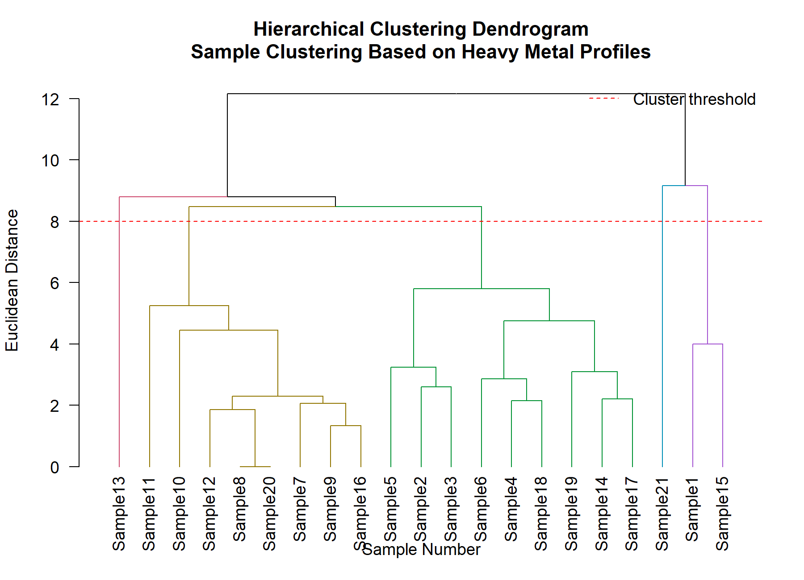
Figure 4. Hierarchical clustering dendrogram of 21 environmental samples based on multi-element heavy metal profiles. Euclidean distance with Ward's linkage. Red dashed line (distance ≈ 8) delineates four discrete clusters (gold, green, magenta, purple).

Description
The dendrogram resolves the 21 samples into four statistically coherent clusters, each reflecting a distinct heavy metal contamination profile. Cluster 1 (gold; Samples 7–12, 16, 20) merges at a relatively low Euclidean distance (≤ 5.3), indicating tight intra-cluster similarity. This group likely represents sampling sites under moderate anthropogenic impact with intermediate concentrations across multiple metals. The early internal coalescence of pairs such as Samples 8 and 20 reflects micro-scale spatial homogeneity, possibly attributable to uniform deposition or dilution by common hydrological processes.

Cluster 2 (green; Samples 2, 3, 4, 5, 6, 14, 17, 18, 19) forms the largest grouping, with internal merging distances ranging from approximately 2.1 to 8.5. The relatively wide internal divergence suggests moderate intra-cluster heterogeneity, consistent with sites sharing a common dominant source but varying in the intensity of secondary inputs. This cluster may characterise sites influenced by diffuse, mixed lithogenic and anthropogenic contamination.

Cluster 3 (magenta; Sample 21 isolated) stands as a singleton cluster, merging with the remaining samples only at the highest Euclidean distance (> 11), confirming that Sample 21 represents the most geochemically anomalous site within the study area. The extreme dissimilarity of this sample corroborates the outlier position observed in the PCA biplot (Figure 3), reinforcing the hypothesis that this site is subject to severe, localised point-source contamination.

Cluster 4 (purple; Samples 1 and 15) forms at a relatively large distance (≈ 9.2), suggesting these two samples share a distinctive heavy metal fingerprint that differs from all other groups, possibly indicative of a unique contamination source or geochemical environment at these locations. The overall cluster structure is consistent with findings from similar environmental studies employing Ward linkage hierarchical clustering for heavy metal source apportionment in aquatic and terrestrial systems (Shrestha & Kazama, 2007; Singh et al., 2004).

References
Shrestha, S., & Kazama, F. (2007). Assessment of surface water quality using multivariate statistical techniques: A case study of the Fuji river basin, Japan. Environmental Modelling & Software, 22(4), 464–475.
Singh, K.P., Malik, A., Mohan, D., & Sinha, S. (2004). Multivariate statistical techniques for the evaluation of spatial and temporal variations in water quality of Gomti River (India). Water Research, 38(18), 3980–3992.
Ward, J.H. (1963). Hierarchical grouping to optimize an objective function. Journal of the American Statistical Association, 58(301), 236–244.

Figure 5: Quartile Distribution of Heavy Metal Concentrations
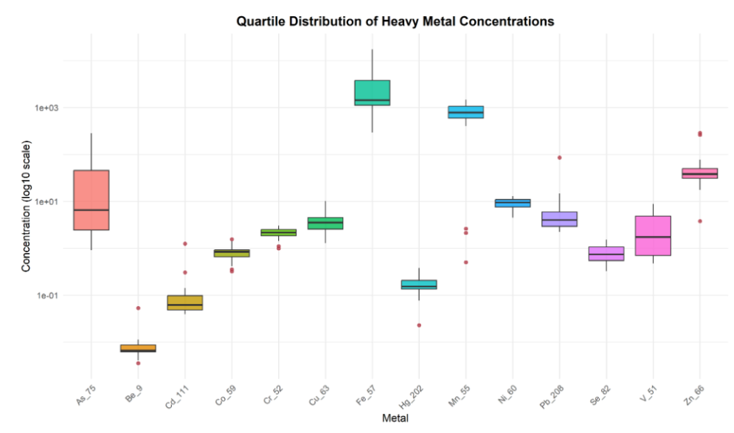
Figure 5. Box-and-whisker plots (log₁₀ scale) summarising the quartile distribution of fourteen heavy metals across 21 environmental samples. Boxes denote the interquartile range (25th–75th percentile); the horizontal line marks the median; whiskers extend to 1.5× IQR; red points denote statistical outliers beyond the whiskers.

Description
Median concentrations span more than five orders of magnitude across the fourteen elements, with Fe (1439.70 mg/kg) and Mn (788.37 mg/kg) dominating absolute abundance by a wide margin over all other metals. This dominance reflects the high natural crustal abundance of Fe and Mn oxides/hydroxides and their conventional use as lithogenic normalisation elements in environmental geochemistry, since their concentrations are governed primarily by parent-material mineralogy rather than contamination (Sutherland, 2000). At the opposite end of the distribution, Be (median 0.01 mg/kg), Cd (0.06 mg/kg) and Se (0.75 mg/kg) occur at trace levels typical of uncontaminated background soils (Kabata-Pendias, 2010).
Applying the variability classification of Wilding (1985) — low (CV < 15%), moderate (15–35%) and high (> 35%) — to the coefficients of variation reveals a clear geochemical grouping. Ni (25.6%) and Cr (26.2%) fall within the moderate-variability class and display the most compact boxes in Figure 5, consistent with a relatively homogeneous, predominantly lithogenic source. Co (37.7%) lies just above this threshold, reinforcing its earlier association with Mn, Ni and Co as a coherent, low-dispersion geochemical cluster identified by correlation analysis (Figure 1) and confirmed by the narrow inter-quartile spread visible here.
In marked contrast, Pb (203.9%), Cd (188.3%), As (176.5%), Fe (127.5%), Zn (121.8%) and Be (110.1%) exhibit extreme variability, each more than three times the Wilding (1985) high-variability threshold. Such pronounced right-skew, with medians falling well below the means and numerous red outlier points above the upper whisker, is the classic statistical signature of a low geogenic baseline overlain by sporadic, high-magnitude anthropogenic inputs at discrete sampling locations rather than a uniformly elevated background (Reimann & Filzmoser, 2000; Reimann & de Caritat, 2005). This pattern is fully consistent with the Be–Pb–Cd anthropogenic source cluster resolved in Figure 1 and with the singleton outlier samples (Samples 13 and 21) subsequently isolated by hierarchical clustering (Figure 4).
Vanadium displays intermediate-to-high dispersion (CV = 87.8%), while Hg, Mn, Cu and Se occupy a narrower intermediate band (42.3–54.4%), suggestive of mixed geogenic and diffuse anthropogenic inputs such as petroleum combustion products or agricultural amendments (Nriagu & Pacyna, 1988), and corroborating the V–Se–Cu association previously identified in the correlation matrix (Figure 1).
Taken together, the mean coefficient of variation across all fourteen metals (≈64%) indicates an overall moderately-to-highly heterogeneous dataset, dominated by a small number of strongly enriched, low-frequency contamination events superimposed on a comparatively stable lithogenic background. This heterogeneity provides the statistical justification for the multivariate clustering (Figure 6) and integrated pollution indexing (Figure 7) presented subsequently, which translate this element-by-element dispersion into sample-level and site-level risk classifications.

References
Kabata-Pendias, A. (2010). Trace Elements in Soils and Plants (4th ed.). CRC Press, Boca Raton.
Nriagu, J.O., & Pacyna, J.M. (1988). Quantitative assessment of worldwide contamination of air, water and soils by trace metals. Nature, 333(6169), 134–139.
Reimann, C., & de Caritat, P. (2005). Distinguishing between natural and anthropogenic sources for elements in the environment: regional geochemical surveys versus enrichment factors. Science of the Total Environment, 337(1–3), 91–107.
Reimann, C., & Filzmoser, P. (2000). Normal and lognormal data distribution in geochemistry: death of a myth. Consequences for the statistical treatment of geochemical and environmental data. Environmental Geology, 39(9), 1001–1014.
Sutherland, R.A. (2000). Bed sediment-associated trace metals in an urban stream, Oahu, Hawaii. Environmental Geology, 39(6), 611–627.
Wilding, L.G. (1985). Spatial variability: its documentation, accommodation and implication to soil surveys. In D.R. Nielsen & J. Bouma (Eds.), Soil Spatial Variability: Proceedings of a Workshop of the ISSS and the SSSA (pp. 166–187). PUDOC, Wageningen.

Figure 6: Clustered Heatmap of Standardised Heavy Metal Concentrations
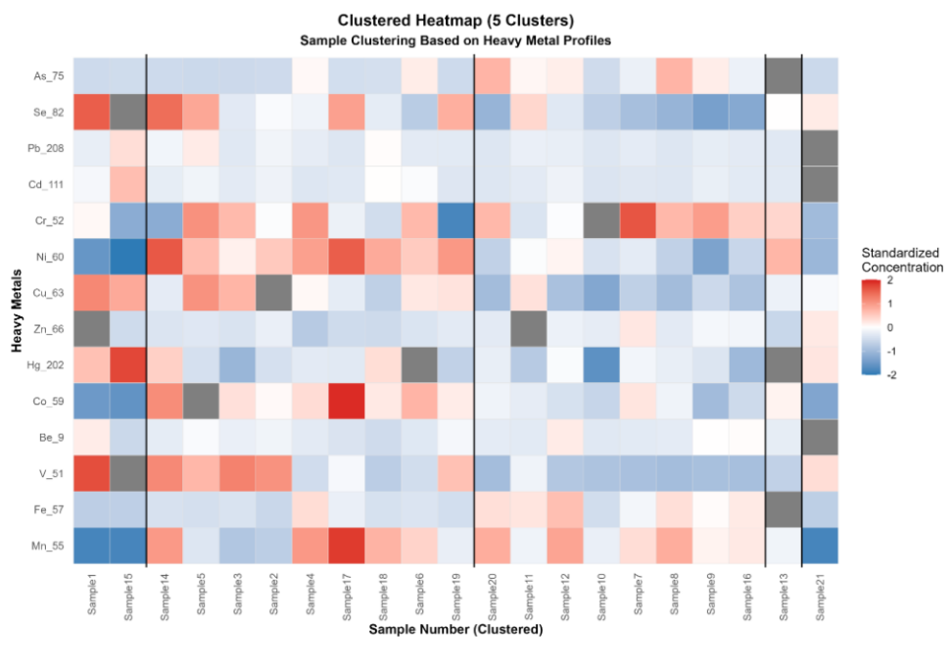
Figure 6. Two-way clustered heatmap of z-score standardised concentrations for fourteen heavy metals (rows) across 21 samples (columns), partitioned into five clusters by hierarchical clustering. Colour intensity denotes standardised deviation from the element-wise mean (red = relative enrichment, blue = relative depletion); grey cells denote values excluded from standardisation; vertical black lines delineate cluster boundaries.

Description
Five-cluster partitioning of the standardised heavy metal matrix refines the broader four-group Ward solution obtained in Figure 4 by further resolving two extreme, single-sample contamination signatures that were previously absorbed into larger groupings. Cluster 2 (Samples 14, 5, 3, 2, 4, 17, 18, 6, 19; n = 9) and Cluster 3 (Samples 20, 11, 12, 10, 7, 8, 9, 16; n = 8) together account for 17 of the 21 samples (81%) and share a common Fe–Mn–Zn enrichment signature (Fe = 1621.7 and 3374.2 mg/kg; Mn = 869.9 and 880.8 mg/kg; Zn = 28.9 and 79.2 mg/kg, respectively), differing principally in the intensity rather than the composition of enrichment. This pattern is consistent with a shared regional lithogenic background modulated by varying degrees of diffuse anthropogenic loading, in agreement with the moderate-variability Fe–Mn association noted in the quartile distributions of Figure 5 (Kabata-Pendias, 2010).
Cluster 1 (Samples 1 and 15; n = 2) displays a comparatively muted version of the same Fe–Zn–Pb signature (Fe = 313.8 mg/kg, Zn = 142.1 mg/kg, Pb = 9.5 mg/kg), corresponding to the purple grouping previously identified in the Ward dendrogram (Figure 4) and to the lowest-ranked samples on the Nemerow pollution index (Figure 7), reinforcing the internal consistency of the multivariate and index-based approaches.
Cluster 4, an isolated singleton comprising only Sample 13, is characterised by an extreme Fe–As–Mn signature (Fe = 17,364.9 mg/kg, Mn = 676.6 mg/kg, As = 283.6 mg/kg), with Fe and As concentrations approximately an order of magnitude above the next most enriched sample. The co-elevation of As and Fe is consistent with the strong As–Fe correlation (r = 0.97) reported in Figure 1 and reflects the well-documented adsorption of arsenate onto iron oxyhydroxide surfaces (Smedley & Kinniburgh, 2002), suggesting that Sample 13 represents a localised, high-magnitude point source — plausibly mine drainage, tailings, or industrial particulate deposition — not separately resolved by the coarser four-cluster solution.
Cluster 5, the second singleton (Sample 21), is distinguished instead by elevated Pb and Zn (Pb = 85.8 mg/kg, Zn = 76.4 mg/kg) alongside comparatively modest Fe (304.8 mg/kg), a compositional fingerprint distinct from Cluster 4 and consistent with the Be–Pb–Cd anthropogenic source identified in the correlation matrix (Figure 1) and with this sample’s prior identification as a geochemical outlier in both the PCA biplot (Figure 3) and the hierarchical dendrogram (Figure 4).
Overall, the two-way clustered heatmap demonstrates that bulk concentration similarity can mask compositionally distinct contamination processes: Samples 13 and 21 occupy markedly different positions along the Fe–As versus Pb–Zn enrichment axes despite both representing the most contaminated extremes of the dataset, underscoring the diagnostic value of clustered heatmap visualisation for source-specific risk screening (Wilkinson & Friendly, 2009; Eisen et al., 1998).

References
Eisen, M.B., Spellman, P.T., Brown, P.O., & Botstein, D. (1998). Cluster analysis and display of genome-wide expression patterns. Proceedings of the National Academy of Sciences, 95(25), 14863–14868.
Kabata-Pendias, A. (2010). Trace Elements in Soils and Plants (4th ed.). CRC Press, Boca Raton.
Smedley, P.L., & Kinniburgh, D.G. (2002). A review of the source, behaviour and distribution of arsenic in natural waters. Applied Geochemistry, 17(5), 517–568.
Ward, J.H. (1963). Hierarchical grouping to optimize an objective function. Journal of the American Statistical Association, 58(301), 236–244.
Wilkinson, L., & Friendly, M. (2009). The history of the cluster heat map. The American Statistician, 63(2), 179–184.

Figure 7: Contamination Indices and Risk Assessment — Integrated Pollution Index (Nemerow)
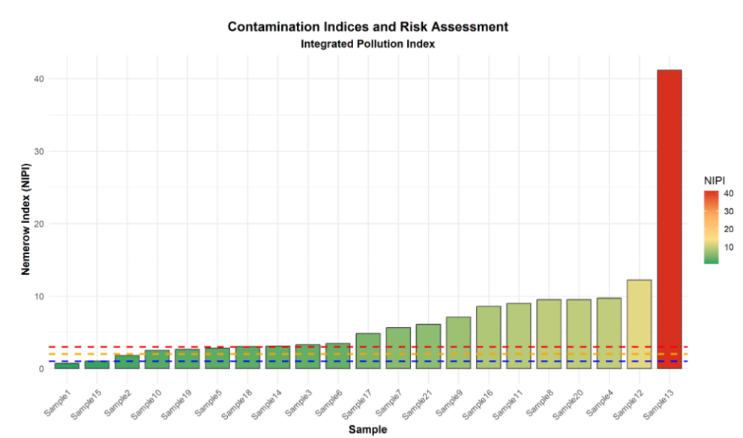
Figure 7. Nemerow Integrated Pollution Index (NIPI) computed for 21 samples from thirteen heavy metals (As, Se, Pb, Cd, Cr, Ni, Cu, Zn, Hg, Co, Be, V, Fe, Mn) against established reference limits. Bars are ranked in ascending order and coloured by NIPI magnitude (green = low risk, red = high risk); dashed horizontal lines mark successive pollution-category thresholds.

Description
The Nemerow Integrated Pollution Index combines the average single-factor pollution index (mean Pi across all measured metals) with the maximum single-factor index (Pi-max for the most contaminated element) to produce a composite score that weights both overall multi-element loading and worst-case single-element exceedance, ensuring that index values are not diluted by averaging a severe single-element exceedance against many unremarkable elements (Nemerow, 1974; Gong et al., 2008). Reference limits applied here range from 3 mg/kg for Cd and 4 mg/kg for Be up to 3000 mg/kg for Zn and 2000 mg/kg for Cu, reflecting the wide natural range of background tolerances across elements with differing toxicity and crustal abundance.
Across the 21 samples, NIPI values range from 0.69 to 41.17 (mean = 7.04, median = 4.84), and the resulting classification is heavily skewed toward the upper end of the risk scale: only one sample is classified as clean and two as low pollution, while three fall into the moderate pollution category and the substantial majority — 15 of 21 samples (71%) — are classified as heavy pollution. This distribution indicates that elevated heavy metal loading is a pervasive, rather than isolated, characteristic of the study area, consistent with the high coefficients of variation reported for several anthropogenically associated elements in Figure 5 (Edet & Offiong, 2002).
Sample 13 returns by far the highest index value (NIPI = 41.17), more than three times the second-ranked sample, driven principally by its extreme As and Fe loadings already identified as a distinct Fe–As contamination signature in the clustered heatmap (Figure 6, Cluster 4). This single sample alone exceeds the heavy-pollution threshold by an order of magnitude, identifying it unambiguously as the most severely impacted site in the dataset and a priority target for remediation.
Sample 12 ranks second (NIPI = 12.22), followed by a tightly clustered group — Sample 4 (9.70), Sample 8 (9.52) and Sample 20 (9.52) — all of which belong to the Fe–Mn–Zn-enriched Clusters 2 and 3 described in Figure 6, indicating that this shared geochemical signature translates into a consistently elevated, though not extreme, pollution classification across the majority of moderately enriched samples.
At the opposite extreme, Samples 1 and 15 return the lowest index values in the dataset, placing them at or near the clean/low-pollution boundary. This is directly consistent with their comparatively muted Fe–Zn–Pb enrichment in Cluster 1 of the heatmap (Figure 6) and their compact, low-magnitude positioning in the quartile distributions (Figure 5), demonstrating strong convergence between the univariate index-based assessment and the independent multivariate clustering analyses.
The high prevalence of heavy-pollution classifications, combined with the disproportionate contribution of As, Fe and Pb to the most severe cases, indicates that contamination in this dataset is driven by a small number of strongly enriched elements at specific sites rather than uniform, low-level diffuse pollution. This finding reinforces the case for targeted, site-specific remediation prioritising Sample 13 and its associated source area, and illustrates the value of combining composite pollution indices with multivariate source-apportionment techniques for robust environmental risk assessment (Backman et al., 1998).

References
Backman, B., Bodiš, D., Lahermo, P., Rapant, S., & Tarvainen, T. (1998). Application of a groundwater contamination index in Finland and Slovakia. Environmental Geology, 36(1–2), 55–69.
Edet, A.E., & Offiong, O.E. (2002). Evaluation of water quality pollution indices for heavy metal contamination monitoring, Qua Iboe River Basin, Nigeria. GeoJournal, 57(4), 295–304.
Gong, Q., Deng, J., Xiang, Y., Wang, Q., & Yang, L. (2008). Calculating pollution indices by heavy metals in ecological geochemistry assessment and a case study in parks of Beijing. Journal of China University of Geosciences, 19(3), 230–241.
Nemerow, N.L. (1974). Scientific Stream Pollution Analysis. Scripta Book Company, Washington, DC.

Figure 8: Heavy Metal Pollution Index (HPI)
Figure 8. Heavy Metal Pollution Index (HPI) computed for 21 samples from the same thirteen-metal panel and reference limits used in Figure 7, ranked in ascending order. Bars are coloured by HPI magnitude (purple = low, orange = high); dashed horizontal lines mark the moderate-risk (HPI = 100) and high-risk (HPI = 200) thresholds.

Description
The Heavy Metal Pollution Index follows the weighted arithmetic sub-index method of Mohan et al. (1996), in which each metal is assigned a unit weight inversely proportional to its recommended standard (permissible) limit, and the sub-indices are summed and normalised by the total weight to yield a single composite score per sample. An HPI below 100 is conventionally interpreted as low risk, values between 100 and 200 as moderate risk, and values of 200 or above as high risk (Mohan et al., 1996; Edet & Offiong, 2002; Balakrishnan & Ramu, 2016).
Across the 21 samples, HPI values range from 7.30 to 294.83 (mean = 48.17, median = 28.96). The overwhelming majority of samples — 20 of 21 (95%) — fall below the moderate-risk threshold and are classified as low risk, while a single sample, Sample 13, exceeds both the moderate (100) and high-risk (200) thresholds with an HPI of 294.83, nearly three times the high-risk cut-off and roughly three times higher than any other sample in the dataset.
A second tier of samples — Sample 21 (97.98), Sample 8 (86.35) and Sample 20 (86.35) — approach but remain just below the 100-point moderate-risk boundary, followed by Sample 12 (56.23) at a more moderate elevation. Although these samples are formally classified as low risk under the Mohan et al. (1996) scheme, their proximity to the moderate-risk threshold suggests they warrant continued monitoring rather than dismissal as unequivocally clean.
The extreme HPI value at Sample 13 is fully consistent with its singleton Fe–As–Mn enrichment signature already identified in the clustered heatmap (Figure 6, Cluster 4) and with its dominant position in the Nemerow Integrated Pollution Index (Figure 7, NIPI = 41.17). Similarly, the comparatively elevated but sub-threshold HPI at Sample 21 mirrors its distinct Pb–Zn enrichment fingerprint (Figure 6, Cluster 5). Notably, however, HPI flags only one sample at its highest risk tier compared with the fifteen samples classified as ‘heavy pollution’ under the Nemerow index (Figure 7); this difference reflects the weighted-arithmetic-mean structure of HPI, which tends to dilute the influence of any single, extremely elevated element across the full thirteen-metal panel, in contrast to the Nemerow index’s explicit weighting toward the maximum single-factor exceedance (Nemerow, 1974).
The convergence of two independently formulated indices — HPI and the Nemerow Integrated Pollution Index — on Sample 13 as the principal contamination hotspot, despite their differing sensitivity and differing overall category-count outcomes, strengthens confidence that this sample represents a genuine, high-priority site for remedial intervention. The divergence in classification of intermediate-tier samples such as Sample 21 further illustrates the value of applying multiple complementary indices in parallel rather than relying on any single metric for environmental risk screening (Edet & Offiong, 2002; Backman et al., 1998).

References
Backman, B., Bodiš, D., Lahermo, P., Rapant, S., & Tarvainen, T. (1998). Application of a groundwater contamination index in Finland and Slovakia. Environmental Geology, 36(1–2), 55–69.
Balakrishnan, A., & Ramu, A. (2016). Evaluation of heavy metal pollution index (HPI) of ground water in and around the coastal area of Gulf of Mannar Biosphere and Palk Strait. Journal of Advanced Chemical Sciences, 2(2), 331–333.
Edet, A.E., & Offiong, O.E. (2002). Evaluation of water quality pollution indices for heavy metal contamination monitoring, Qua Iboe River Basin, Nigeria. GeoJournal, 57(4), 295–304.
Mohan, S.V., Nithila, P., & Reddy, S.J. (1996). Estimation of heavy metals in drinking water and development of heavy metal pollution index. Journal of Environmental Science and Health, Part A, 31(2), 283–289.
Nemerow, N.L. (1974). Scientific Stream Pollution Analysis. Scripta Book Company, Washington, DC.

Figure 9: Geoaccumulation Index (Igeo) Heatmap and Source Apportionment by Factor Analysis
Figure 9. (a) Heatmap of the geoaccumulation index (Igeo) for seven heavy metals (As, Cr, Cu, Fe, Mn, Pb, Zn) across 21 samples, calculated relative to regional background values; colour scale ranges from blue (depletion/uncontaminated) to dark red (Igeo ≥ 5, extreme contamination). (b) Factor loadings from a three-factor exploratory factor analysis of the same seven metals; dashed red lines denote the ±0.5 threshold conventionally used to define a strong metal–factor association.

Description
The geoaccumulation index quantifies enrichment relative to a regional geochemical background using the classification scheme of Müller (1969): Igeo ≤ 0 indicates a practically uncontaminated sample, 0–1 uncontaminated-to-moderately contaminated, 1–2 moderately contaminated, 2–3 moderate-to-strong, 3–4 strong, 4–5 strong-to-extreme, and Igeo > 5 extreme contamination. Within panel (a), arsenic displays by far the widest range of variation across the sample set and contains the single most extreme cell in the entire matrix (deep red, Igeo ≈ 5), located at Sample 13 — consistent with the extreme As loading already identified in the singleton Fe–As cluster of Figure 6 and with the dominant arsenic contribution to both the Nemerow Index (Figure 7) and the Heavy Metal Pollution Index (Figure 8).
Chromium shows uniformly muted, near-neutral to slightly negative cells across almost all 21 samples, indicating concentrations consistently close to or below the regional background. This pattern agrees with chromium’s comparatively low coefficient of variation reported in the quartile distribution (Figure 5, CV = 26.2%) and with its membership in the homogeneous, low-dispersion Mn–Ni–Co geochemical cluster identified by correlation analysis (Figure 1).
Lead and zinc, by contrast, each display isolated, strongly enriched cells at discrete samples — most prominently at Sample 21 — set against an otherwise unremarkable background across the remaining locations. This localised enrichment mirrors the Pb–Zn-dominated Cluster 5 signature previously identified for Sample 21 in the clustered heatmap (Figure 6), reinforcing its classification, alongside Sample 13, as one of two compositionally distinct point-source outliers within the dataset.
Panel (b) statistically corroborates these visual patterns through exploratory factor analysis. Factor 1 loads strongly and almost exclusively on As (0.98) and Fe (0.94), with negligible loading on the remaining five metals, identifying a single, well-defined latent source that closely parallels the strong As–Fe correlation already established in Figure 1 (r = 0.97) and the Cluster 4 (Sample 13) signature in Figure 6 — consistent with the well-documented co-precipitation of arsenate onto iron oxyhydroxide mineral surfaces (Smedley & Kinniburgh, 2002).
Factor 2 is characterised by a strong positive Cu loading (0.70) counterbalanced by a strong negative Mn loading (−0.82), pointing to an inverse relationship between a Cu-associated input — plausibly linked to agricultural or fungicidal copper use — and Mn behaviour, which is consistent with redox-sensitive manganese mobilisation under contrasting depositional conditions (Tessier et al., 1979). Factor 3 instead combines a strong negative Pb loading (−0.66) with a moderate positive Cr loading (0.42) and a weak positive Zn loading; this pattern does not correspond cleanly to an established lithogenic or anthropogenic source category and may instead reflect a sample-specific effect disproportionately influenced by Sample 21, underscoring the need for cautious interpretation of minor factors in a dataset of this size (Kim & Mueller, 1978).
Taken together, the Igeo heatmap and the factor loadings converge on two principal contamination axes already identified in earlier figures — a Fe–As-dominated point source captured by Factor 1 and attributable to Sample 13, and a more diffuse Pb–Zn-associated input linked to Sample 21 — while confirming that chromium, and by extension the broader lithogenic background, remains close to regional baseline levels across the large majority of sampled locations.

References
Kim, J.-O., & Mueller, C.W. (1978). Factor Analysis: Statistical Methods and Practical Issues. Sage Publications, Beverly Hills.
Müller, G. (1969). Index of geoaccumulation in sediments of the Rhine River. GeoJournal, 2(3), 108–118.
Smedley, P.L., & Kinniburgh, D.G. (2002). A review of the source, behaviour and distribution of arsenic in natural waters. Applied Geochemistry, 17(5), 517–568.
Tessier, A., Campbell, P.G.C., & Bisson, M. (1979). Sequential extraction procedure for the speciation of particulate trace metals. Analytical Chemistry, 51(7), 844–851.

Figure 10: Spatial Pattern Analysis by PCA-Based Sample Ordering
Figure 10. Concentration of seven heavy metals (As, Cr, Cu, Fe, Mn, Pb, Zn) plotted against sample order derived from PC1 scores. Blue points and connecting lines show observed concentrations; red dashed lines with grey shaded bands represent linear trend fits with 95% confidence intervals.

Description
Ordering the 21 samples along PC1 — the dominant axis of multivariate variance, which accounts for the largest share of total variance in the dataset (Figure 2) — converts an otherwise arbitrary sample sequence into an implicit contamination gradient, allowing the behaviour of each element to be examined for systematic trends that would not be visible under raw sample-ID ordering (Grunsky, 2010).
Arsenic, iron and manganese display the clearest and most consistent positive trends along the PC1-ordered axis, with concentrations rising several-fold from the lowest- to the highest-ranked samples and culminating in a sharp upward spike at the final, highest-PC1 sample — corresponding to the extreme Sample 13 values already flagged in the clustered heatmap (Figure 6), the geoaccumulation index (Figure 9), and both composite pollution indices (Figures 7 and 8). The comparatively tight confidence band for manganese, relative to the wider bands for arsenic and iron, indicates a more continuous, monotonic increase for Mn, whereas As and Fe are more strongly influenced by this single extreme terminal value.
Chromium also exhibits a positive but markedly noisier trend, oscillating within a narrow concentration range across the ordered sequence without the late-sequence spike seen for As, Fe and Mn. This is consistent with chromium’s comparatively low coefficient of variation (Figure 5) and its largely background-level Igeo values (Figure 9), suggesting that its modest positive trend reflects a weak, diffuse association with the dominant gradient rather than a discrete point source.
Copper, lead and zinc show the converse pattern: a negative trend along the PC1-ordered axis, with the highest concentrations of each clustering toward the low end of the sample order and a general decline thereafter, punctuated by isolated peaks such as lead’s pronounced outlier near the start of the sequence. This inverse relationship to the rising Fe–As–Mn trio indicates that Cu, Pb and Zn are not governed by the same underlying process as the dominant gradient, consistent with the partially independent variance structure noted for these metals in the correlation matrix (Figure 1) and with the comparatively localised Igeo enrichment observed for Pb and Zn outside of the Sample 21 hotspot (Figure 9).
The divergence between the rising As–Fe–Mn trio and the declining Cu–Pb–Zn trio along the same ordinal axis demonstrates that the dominant multivariate gradient captured by PC1 is not a generic, single ‘overall contamination’ axis but specifically reflects the Fe–As–Mn point-source signal associated with Sample 13, while Cu, Pb and Zn instead follow an independent, comparatively minor secondary gradient. This reinforces the multi-source interpretation already established through correlation analysis (Figure 1), hierarchical and heatmap clustering (Figures 4 and 6), and factor analysis (Figure 9).

References
Grunsky, E.C. (2010). The interpretation of geochemical survey data. Geochemistry: Exploration, Environment, Analysis, 10(1), 27–74.
Jolliffe, I.T. (2002). Principal Component Analysis (2nd ed.). Springer, New York.
Kaiser, H.F. (1960). The application of electronic computers to factor analysis. Educational and Psychological Measurement, 20(1), 141–151.
Reimann, C., Filzmoser, P., Garrett, R.G., & Dutter, R. (2008). Statistical Data Analysis Explained: Applied Environmental Statistics with R. Wiley, Chichester.

Figure 11: Exposure Pathway Analysis and Metal-Specific Risk Contribution
Figure 11. (c) Hazard Index (HI) contribution by exposure pathway — ingestion, inhalation and dermal contact — for the five samples with the highest integrated non-carcinogenic risk. (d) Total hazard quotient summed across all 21 samples for each of fourteen heavy metals, ranked by metal-specific risk contribution.

Description
Non-carcinogenic risk for each metal and exposure route is expressed as a hazard quotient (the ratio of estimated chronic daily intake to the corresponding reference dose); pathway-specific hazard quotients are then summed across all metals and routes to yield the Hazard Index (HI) for each sample, with HI > 1 conventionally interpreted as indicating a potentially unacceptable cumulative non-carcinogenic risk (USEPA, 1989; Ferreira-Baptista & De Miguel, 2005).
Sample 13 dominates panel (c), returning a Hazard Index of 32.2 — roughly 3.4 times higher than the next-ranked samples, Sample 8 and Sample 20 (HI = 9.5 each), and more than thirty times the conventional acceptability threshold of HI = 1. This result is the direct downstream consequence of the extreme arsenic and iron enrichment already identified at this location through the geoaccumulation index (Figure 9) and the PCA-based spatial gradient analysis (Figure 10), and corroborates its position as the highest-ranked sample under both composite pollution indices (Figures 7 and 8), confirming Sample 13 as a consistent, multi-method priority site for risk management.
Across all five top-ranked samples, ingestion is overwhelmingly the dominant exposure pathway, accounting for the large majority of each sample’s Hazard Index, while inhalation and dermal contact contribute comparatively minor shares throughout. This pattern is consistent with the well-established dominance of incidental soil and dust ingestion as the principal non-carcinogenic exposure route for trace metals in non-occupational settings (USEPA, 1989; Ferreira-Baptista & De Miguel, 2005).
Panel (d) shows that arsenic contributes overwhelmingly to the cumulative metal-specific hazard quotient summed across all 21 samples (81.6), exceeding the combined contribution of all other thirteen metals (which together total approximately 11.5) and more than twenty times higher than the next-ranked metal, manganese (3.7). Iron (2.8) and lead (1.7) form a secondary tier of moderate contributors, while chromium, mercury, nickel, vanadium, zinc, selenium, cadmium, copper, cobalt and beryllium each contribute less than 0.5 to the cumulative hazard quotient, indicating negligible non-carcinogenic risk from these elements at the concentrations observed in this dataset.
The convergence of panels (c) and (d) demonstrates that the human health risk profile of this dataset is overwhelmingly driven by a single metal (arsenic) acting through a single dominant exposure route (ingestion) at a single hotspot location (Sample 13), rather than by diffuse, multi-element contamination across the sample set. This is consistent with arsenic’s recognised high oral toxicity and correspondingly low reference dose relative to most other trace metals (ATSDR, 2007) and reinforces the case, established throughout Figures 6 to 10, for prioritising targeted investigation and remediation at the Sample 13 source area as the single most effective risk-reduction measure available for this site.

References
ATSDR. (2007). Toxicological Profile for Arsenic. Agency for Toxic Substances and Disease Registry, U.S. Department of Health and Human Services, Atlanta, GA.
Ferreira-Baptista, L., & De Miguel, E. (2005). Geochemistry and risk assessment of street dust in Luanda, Angola: A tropical urban environment. Atmospheric Environment, 39(25), 4501–4512.
USEPA. (1989). Risk Assessment Guidance for Superfund, Volume I: Human Health Evaluation Manual (Part A). EPA/540/1-89/002. Office of Emergency and Remedial Response, Washington, DC.

Conclusion : Collectively, the eleven figures constitute a comprehensive, multi-method statistical and risk-assessment framework for heavy metal source apportionment and environmental management. The correlation matrix (Figure 1) identifies inter-element associations; the scree plot (Figure 2) justifies dimensionality reduction; the PCA biplot (Figure 3) reveals source–sample relationships in reduced space; and the hierarchical dendrogram (Figure 4) classifies sampling sites into geochemically coherent groups. The quartile distribution plot (Figure 5) quantifies the central tendency and dispersion of each element, separating low-variability lithogenic metals from high-variability, point-source-affected contaminants; the clustered heatmap (Figure 6) refines sample classification and isolates two compositionally distinct, single-sample contamination signatures (Samples 13 and 21); and the Nemerow Integrated Pollution Index (Figure 7) and Heavy Metal Pollution Index (Figure 8) translate these multivariate patterns into composite risk categories, independently converging on Sample 13 as the most severely contaminated location. The geoaccumulation index and factor analysis (Figure 9) attribute this contamination to a distinct Fe–As geochemical source, while PCA-based spatial ordering (Figure 10) confirms that this source drives the dominant multivariate gradient across the sample set, independent of a secondary Cu–Pb–Zn signal. Finally, the exposure pathway and metal-specific risk analysis (Figure 11) demonstrates that the resulting human health risk is overwhelmingly attributable to arsenic ingestion at Sample 13, providing a clear, evidence-based basis for prioritising remediation. Together, these eleven analyses provide a coherent, internally consistent basis for spatial risk assessment and the prioritisation of remediation efforts.

